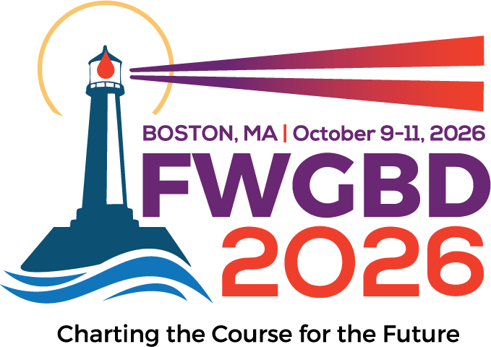
FWGBD Jeanette Doner Mann Travel Award Application
Please follow the instructions below. Completed applications should be emailed to kfunkhouser@fwgbd.org.
Use as much space as you need to answer the questions below.

- Applicant Information
- Name:
- E-mail:
- Phone:
- FWGBD Membership Number:
- Date of application:
- Year in Medical School:

- In 500 words or less, please describe your interest and reasons for attending this conference. (Please type.)

- Program Director/Chair Information
- Name:
- E-mail:
- Phone:

Please submit all items as a single PDF. A complete application includes application sheet filled out (typed), copy of Program Director/Chair’s letter certifying your status in the program and indicating the type of program and specifying the expected completion date submitted with FWGBD membership application, and a copy of your FWGBD 2026 conference registration confirmation.
I agree that I forfeit the awarded grant if I fail to participate in this conference.

